NYC Housing Central Tendency — 1-Page Summary
Brooklyn • Manhattan • Queens | One-bedroom asking rents (synthetic realistic sample, n=180 each)

Problem Statement
What is the typical cost of a one-bedroom apartment in Brooklyn, Manhattan, and Queens? Because housing prices are right-skewed (luxury outliers), the arithmetic mean alone misleads. We compute mean, median, and mode for each borough, diagnose skew, surface assumptions, and adapt the same numbers for analysts, executives, and the public.

Solution Strategy
1) Load three CSVs → extract rent vectors. 2) Compute mean (sum/n & mean()), median (sort + median()), mode (table max / DescTools). 3) Side-by-side comparison table. 4) Histograms with vertical reference lines. 5) Audience-aware rewrites. 6) Monte-Carlo noise simulation to test stability of each measure.

Solution
Borough | Mean ($) | Median ($) | Mode ($)
Brooklyn | 2,940 | 2,799 | 2,500
Manhattan | 3,937 | 3,787 | 3,500
Queens | 2,435 | 2,252 | 2,000
Ordering Mode ≤ Median ≤ Mean holds in every borough → consistent right skew. Manhattan highest on all three measures; Queens lowest; Brooklyn intermediate. Mean is 5–8 % above median because of the upper tail.
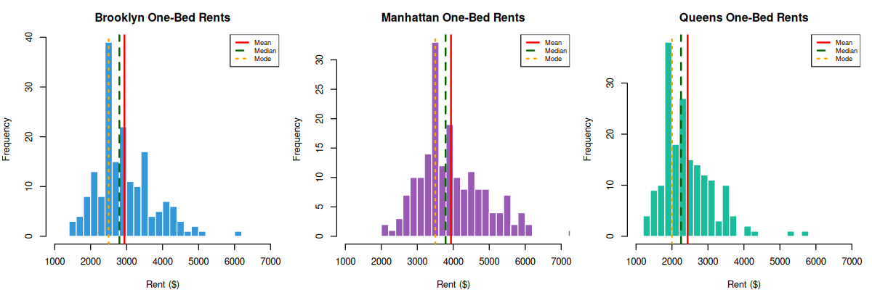
Figure: Histograms with mean (red), median (green dashed), mode (orange dotted)

Key Takeaways
• Prefer the median for “typical rent”; the mean is inflated by luxury units.
• Mode = most common listing price — useful for search filters and market pulse.
• Always state assumptions (representativeness, quality comparability, time window).
• Re-phrase the same three numbers: full table + skew for analysts; median + implication for executives; “most common price” story for the public.
• Simulation: median is robust to additive noise; raw mode is fragile (binning restores usability).

